**NAT vs Bastion**

**VPC diagram:**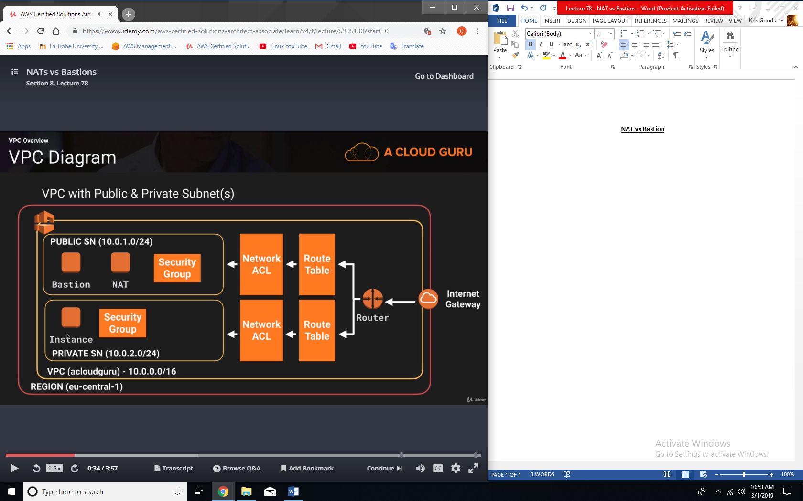

**Bastions:**

* Bastions are used just for administration only.
* The idea is that instead of harden a fleet of instances off your security group, you just have one hardened Bastion and then you access all your instances and subnet through that hardened Bastion.

**Exam tips:**

* A NAT is used to provide internet traffic to EC2 instances in private subnets.
* A Bastion is used to securely administer EC2 instances (using SSH or RDP) in private subnets. In Australia we call them jump boxes.